**Healthy Diet (For Obesity)**

(Including Breakfast, Lunch and Dinner Plus Snacks)

* Oats 1.6Kg - Enough for 30 meals
  + Brought from Chuk Yuen Market
  + Approximately $20 per 800gram
  + Price: $40
* Chicken Chops (Large) 21 Pieces – Enough for 30 meals
  + Brought from market
  + Approximately ~ $11 per Piece
  + Price: $231

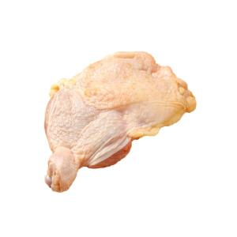

* Vegetables 5kg - Enough for 30 meals
  + Brought from market
  + Approximate $12 per kg
  + Price $60

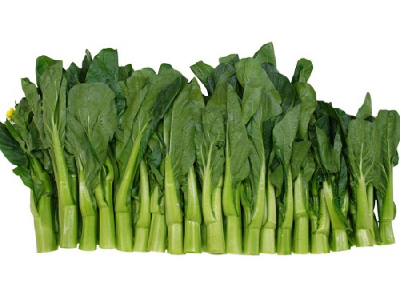

* Best Mart 360 Premium Thai Fragrant Rice 5kg – Enough for 30 meals
  + Brought from Best Mart 360
  + Approximately ~ $49 per packet
  + Price: $49

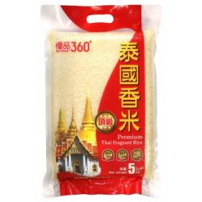

* Devondale Milk 8 large boxes 1 Liter - Enough for 60 snacks
  + Brought from ParknShop supermarket
  + Price $143.2

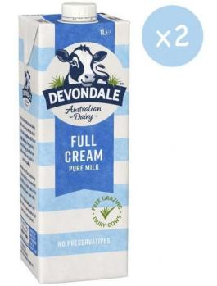

* Nissan Oats Granola 500GM
  + Brought from Best Mart 360
  + Approximate $36
  + Price: $36

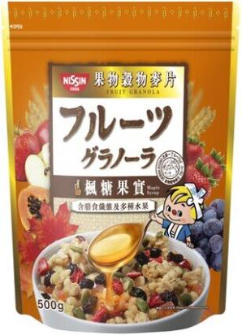

* Longevity Filled Evaporated Milk 3 cans 400GM
  + Brought from welcome supermarket
  + Approximate $9 per can
  + Price: $27

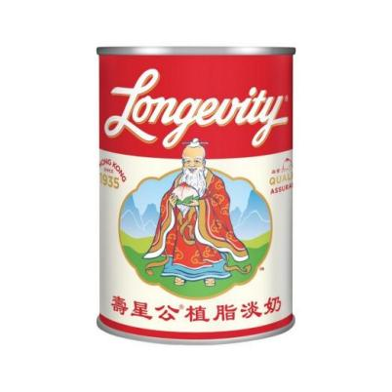

**Total Price: Approximate $586.2 (All in terms of Hong Kong Dollars)**

*Updated: 20th March 2025 price subject to change*

**Ingredients And Menus (Total 90 Meals Plus Snacks)**

3 Meals Per Day (Breakfast, Luch and Dinner Plus Snacks) for 30 days

**These ingredients are based on portions. In case you don’t how to accurately divide it into portion. You can use a balance to weight the net weight of the ingredients and then divide it into portions base on the net weight.**

* Breakfast meal *– (30 meals) (Served for Breakfast)*
  + Sweet Oat meal with Evaporated Milk (8 spoonfull of dried Oats, equilvanent to 40 grams, 40ml of Evaporated Milk, little bit of sugar).
* Morning Snack 10:00 AM *– (30 meals~ 125gram) (Served for Morning Snack 10:00AM)*
  + After night Yogurt with Granola.
* Luch meal*– (30 meals) (Served for Lunch)*

1. Chicken 2.8 onces (80 grams)
2. Vegetables not less than 2/3 Bowl (~ 80gram).
3. Rice 1 2/5 (one and two fifth fractional) Bowl (~ 120 - 150 gram).

* Afternoon Snack 16:00 PM *– (30 meals ~ 125gram) (Served for Afternoon Snack 16:00PM)*
  + After night Yogurt with Granola.
* Dinner *– (30 meals) (Served for Dinner)*
  + Chicken 2.8 onces (80 grams)
  + Vegetables not less than 2/3 Bowl (~ 80gram).
  + Rice 1 2/5 (one and two fifth fractional) Bowl (~ 120 - 150 gram).
* Everyday
  + Only allow 3 tea spoon of oil.
  + One Bowl equals 300 milligrams (300 grams).